2022考研英语二大作文真题解析
来源：文都教育
2022全国硕士研究生招生考试在2021年12月25日这一天正式拉开帷幕，文都集团作为考研行业的领头军，会为广大考生提供2022考研真题及解析。2022考研英语二大作文依然延续之前的图表作文，中国总快递件数和农村快递件数在2018、2019、2020年期间的变化，整体难度不大，按照经典三段论结构走，首段描图，二段分析，尾段总结，现作参考范文如下：

48. Directions:

Write an essay based on the following chart. In your writing, you should
l) interpret the chart and
2) give your comments.
You should write at least 150 words on the ANSWER SHEET 2. (15 points)

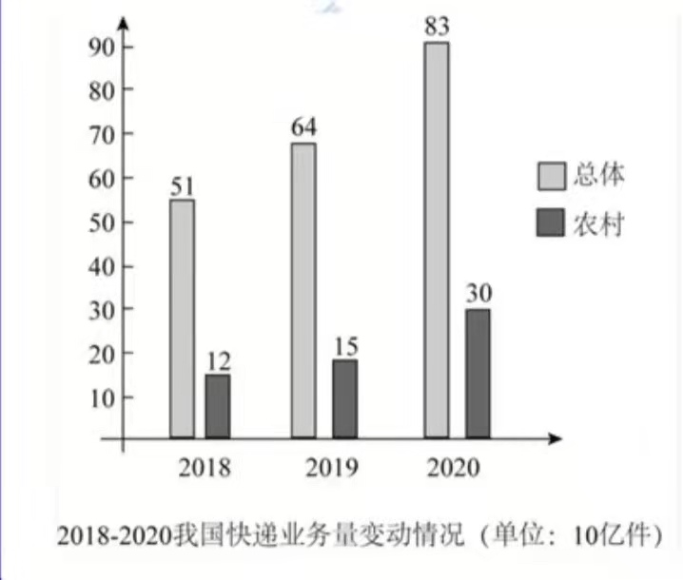

参考范文：
What is profoundly demonstrated in the above column chart is that dramatic changes have taken place in the total and rural amount of China’s expressage from 2018 to 2020. The total number of China’s expressage increased from 51 billion in 2018 to 64 billion in 2019 and then to about 83 billion in 2020, and meanwhile the number of the rural expressage also significantly jumped from about 12 billion to 15 billion and then to 30 billion in the same period.
The column chart illustrates the phenomenon that people in mounting numbers prefer to purchase goods online delivered by the expressage which ascends impressively both in total and the rural. Three reasons, in my belief, can account for this trend. First and foremost, with the acceleration of the society and economy enormously boosting people’s livelihood, the dramatic increase of expressage has inevitably turned out to be a prevailing trend. Moreover, the fast pace of modern life and the fierce competition of society result in people’s gradually changed values, leading more and more people tend to put much emphasis on their convenience in order to save time and energy. Furthermore, relevant policies issued by the authorities and government advance the development of the China’s expressage, especially in the rural areas.
From what have been analyzed above, it can be confidently concluded that this is the natural result of social and economic development, which complies with the interest of both the country and the people. Accordingly, it can be predicted that with the collaboration of the government and individuals, this trend will definitely continue in the forthcoming years.

中文译文：
上面的柱状图深刻地表明，从2018年到2020年中国的快递业务总量和农村快递业务量发生了巨大的变化。中国快递业务总量从2018年的510亿增加到2019的640亿,然后在2020年增加到830亿, 同时农村快递业务的数量也大幅跃升，在同一时期，由 120亿到150亿, 然后骤增至300亿。
该柱状图展示了越来越多的人们倾向在网上购物导致快递激增的现象，无论是全国快件总量还是农村快件数量的增长都令人印象深刻。个人认为以下三个因素可以解释这种趋势。首先，社会和经济的快速发展极大地提高了人民的生活水平，网购促使快递急剧增长不可避免地变成了一个普遍的趋势。此外，现代生活的快节奏和社会的激烈竞争导致人们的价值观年逐渐改变，使得越来越多的人为了节省时间和精力倾向于注重便利性。而且，有关部门和政府发布的相关政策也促进了中国快递行业的发展，特别是在农村地区。
鉴于上述分析，可以自信地得出结论，该现象是社会经济发展的自然结果，符合国家和人民的利益。因此，可以预测，在政府和个人的共同作用下这一趋势肯定会在未来几年继续下去。

以上就是文都集团为广大考生提供的2022考研英语（二）大作文真题及解析。最后文都集团祝广大考生一战成硕，金榜题名！

