2022考研英语写作考查目标分析

来源：文都教育

在万千考研学子期盼的目光中，2022考研英语大纲已于今早发布，文都集团专门针对2022年大纲中的作文模块与去年考纲进行深度剖析对比，为考生提供应对策略。
整体来说，2022年考研英语大纲写作考查目标、考试形式、考试内容与试卷结构基本没有变化。以英语（一）写作为例：作文30分（应用文10分+短文写作20分）
考查目标中要求考生应能写不同类型的应用文，包括私人和公务信函、备忘录、报告等，以及一般描述性、叙述性、说明性或议论性的文章。下面让文都教育带领大家一起先来看看去年大纲英语（一）的作文真题：
2021英语一大作文
Part B
52. Directions:
Write an essay of 160- 200 words based on the following drawing. In your essay, you should
1) describe the drawing briefly,
2) interpret its intended meaning, and then
3) give your comments.
You should write neatly on the ANSWER SHEET. (20 points)
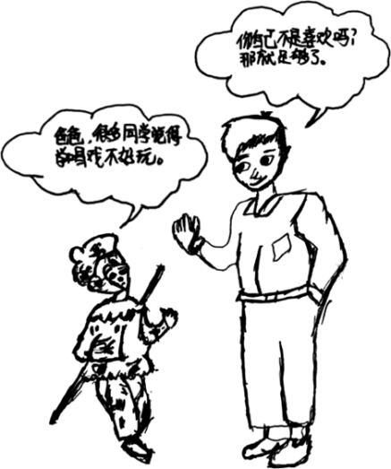
2021英语一小作文
Part A
51. Directions:
A foreign friend of yours has recently graduated from college and intends to find a job in China. Write him / her an email to make some suggestions.
You should write about 100 words on the ANSWER SHEET.
Do not sign your own name at the end. Use “Li Ming” instead.
Do not write the address. (10 points)
而英语（二）写作：作文25分（应用文10分+短文写作15分）
考查目标则是要求考生应能根据所给的提纲、情景或要求完成相应的短文写作。短文应中心思想明确、切中题意、结构清楚、条理清楚、用词恰当、无明显语言错误。英语（二）写作真题如下：
2021英语二大作文
Part B
Directions:
Write an essay based on the chart below. In your writing, you should
interpret the chart, and
give your comments
You should write about 150 words on the ANSWER SHEET. (15 points)
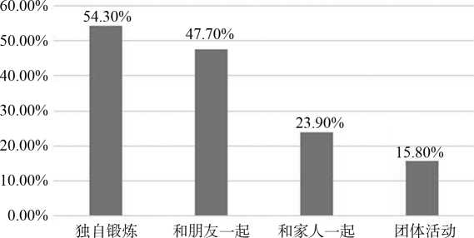
某市居民体育锻炼方式调查
2021英语二小作文
Part A
Directions:
Suppose you are organising an online meeting. Write an e-mail to Jack, an international student.
invite him to participate, and
tell him the details
You should write neatly on the ANSWER SHEET.
Do not sign your own name at the end of the e-mail. Use “Li Ming” instead. (10 points)
通过通读最新考纲，主观题基本没有太大变化，英语一大作文主要是考查学生正确的人身观、价值观和世界观；英语二大作文则要求考生能够紧贴民生实事。而对于小作文来说，历年考查主要以书信为主，所以文都考研再次温馨提醒备考考生冲刺阶段的复习务必要重视格式正确、语言准确。提高和冲刺阶段的备考中，广大考生们一定要调整好心态。
文都考研预祝大家一战成硕，上岸成功。

